BACK TO MUGHAL ERA – GOLDEN TRIANGLE

22ND FEB’26 : ARRIVE DELHI
Meeting and assistance upon arrival at Delhi International Airport, followed by a transfer to the hotel. Upon arrival, check in at the hotel in Delhi

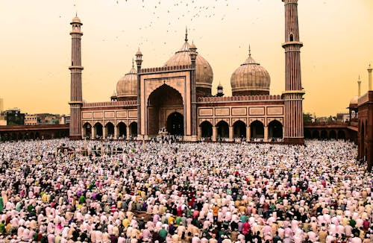
23RD FEB’26: DELHI
Morning after breakfast, discover the timeless charm of Delhi, a city where ancient heritage and modern vibrancy coexist seamlessly. India’s capital offers a rich tapestry of history, culture, and architecture, reflecting centuries of dynasties, empires, and cultural influences. Begin your sightseeing tour in Old Delhi, where narrow lanes, bustling bazaars, and historic landmarks narrate stories of the Mughal era. Visit the iconic Jama Masjid, one of the largest mosques in Asia, followed by a panoramic drive past the majestic Red Fort, a UNESCO World Heritage Site and a symbol of India’s rich past. Experience the lively atmosphere of Chandni Chowk, a centuries-old market renowned for its vibrant streets and traditional flavors.

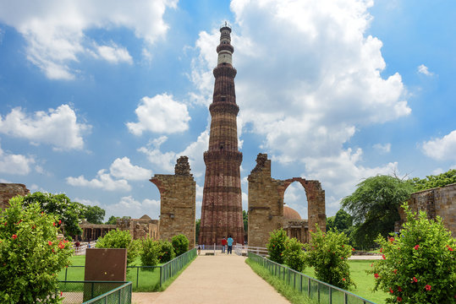
Transition to New Delhi, designed during the British era, is characterized by wide boulevards and grand architecture. Drive past the ceremonial Rajpath, India Gate, Parliament House, and the President’s House, showcasing the city’s colonial legacy and administrative grandeur. Explore the elegant Humayun’s Tomb, a UNESCO World Heritage Site and a precursor to the Taj Mahal, set amidst beautifully landscaped gardens. Continue to Qutub Minar, the world’s tallest brick minaret and another UNESCO-listed monument, admired for its intricate carvings and historical significance. Depending on time, a visit to the serene Lotus Temple or Akshardham Temple offers a glimpse into Delhi’s spiritual diversity and contemporary architectural brilliance.
Overnight stay at a Delhi hotel.

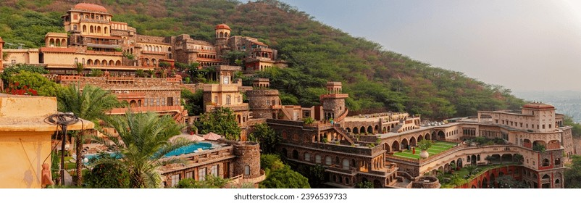
24TH FEB’26: DELHI – NEEMRANA – JAIPUR (269Kms, 05Hrs drive)
Morning after breakfast, drive to Jaipur en route Neemrana Fort: Perched majestically on the Aravalli Hills, Neemrana Fort Palace is a magnificent 15th-century heritage fort that reflects the grandeur of Rajasthan’s royal legacy. Once the residence of the Chauhan rulers, the fort has been meticulously restored and transformed into a world-class heritage hotel, offering an unforgettable blend of history, luxury, and timeless elegance. Spread across multiple terraced levels, the fort showcases an exquisite fusion of Rajput and Mughal architecture, featuring grand courtyards, regal halls, vintage artifacts, and panoramic views of the surrounding countryside. As you explore the fort, each passage and balcony narrates stories of valor, romance, and royal splendor.

Continue drive to Jaipur. Upon arrival, check in at the hotel in Jaipur. Overnight stay at Jaipur hotel.

25TH FEB’26: JAIPUR
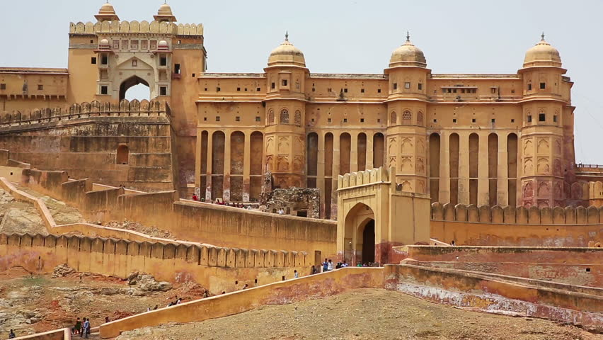
Morning Visit the ancient Rajput capital of Amber, located just 11 km from Jaipur, and experience one of Rajasthan’s most magnificent hill forts. Begin your visit with a memorable ascent to the fort (traditionally by elephant ride, subject to availability), offering a regal introduction to this historic stronghold. Constructed in the late 16th century by Raja Man Singh, Amber Fort served as the seat of power for the Rajput rulers until Maharaja Sawai Jai Singh II established the new capital at Jaipur. Built in a harmonious blend of Rajput and Mughal architecture, the fort-palace complex is renowned for its grandeur and artistic refinement. Explore the Diwan-i-Aam (Hall of Public Audience), the revered Kali Temple, the splendid Jai Mandir or Hall of Victory, celebrated for its intricately inlaid panels and shimmering mirror ceilings, and the cooling Sukh Niwas, designed with a natural water-flow system to provide relief from the summer heat. Perched above Maota Lake, Amber Fort offers breathtaking panoramic views of the surrounding hills and the tranquil waters below, making it one of the most iconic and photogenic landmarks of Rajasthan.

Afternoon Enjoy a half-day sightseeing tour of Jaipur, exploring its most iconic landmarks that reflect the city’s royal heritage and scientific brilliance. Begin with a visit to the Maharaja’s City Palace, located within Jaipur’s historic walled city. Built in 1732 AD, this magnificent palace complex occupies nearly one-seventh of the old city and continues to be a symbol of Jaipur’s regal legacy.
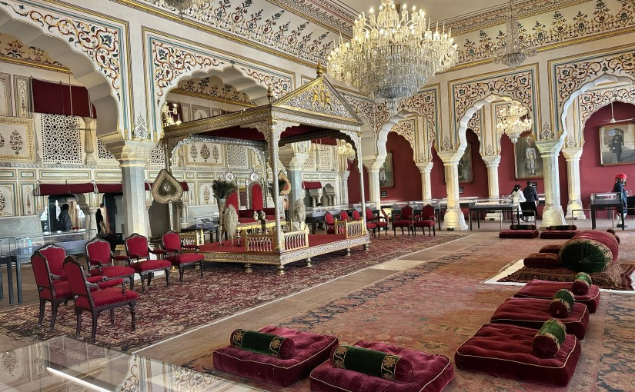
Explore the elegant Mubarak Mahal, along with its fascinating textile and armoury museums, showcasing royal costumes, weaponry, and artifacts from centuries past. Visit the Diwan-i-Khas (Hall of Private Audience) and Diwan-i-Aam (Hall of Public Audience), where the rulers once conducted state affairs and public hearings. Continue to the Jantar Mantar Observatory, a UNESCO World Heritage Site and the oldest astronomical observatory in India. Meaning “instruments for measuring the harmony of the heavens,” Jantar Mantar features a remarkable collection of large-scale astronomical instruments, each precisely designed to measure time, track celestial bodies, and provide highly accurate astronomical readings. Conclude the tour with a photo stop at the Hawa Mahal (Palace of the Winds), Jaipur’s most recognizable façade, famed for its intricately carved pink sandstone windows. Drive past the city’s distinctive rose-pink residential and commercial areas, offering a glimpse into the vibrant daily life of the Pink City.
Overnight stay at Jaipur hotel.

26TH FEB’26: JAIPUR – ABHANERI – FATEHPUR SIKRI – AGRA (257Kms, 05Hrs drive)
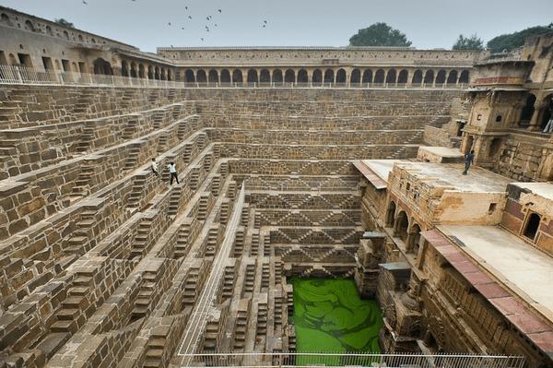
Morning after breakfast drive to Agra enroot visiting Abhaneri: Based on stylistic and architectural similarities with the terraced temples of Paranagar and Mandore, historians date Chand Baori to the 8th–9th century, making it an outstanding example of early water architecture in India. Archaeological assessment suggests that the stepwell was likely constructed prior to the adjoining Harshat Mata Temple, underscoring its primary role as a vital water source for the region. Chand Baori is particularly notable for its extraordinary geometric precision and monumental scale, featuring thousands of symmetrically arranged steps descending to the water level. As observed by architectural historian Morna Livingston in Steps to Water: The Ancient Stepwells of India, Chand Baori is one of the rare stepwells that embodies “two classical periods of water building in a single setting,” highlighting its historical continuity and architectural evolution. Today, Chand Baori stands as a remarkable testament to India’s ancient engineering ingenuity, seamlessly blending functionality, spirituality, and aesthetic excellence.

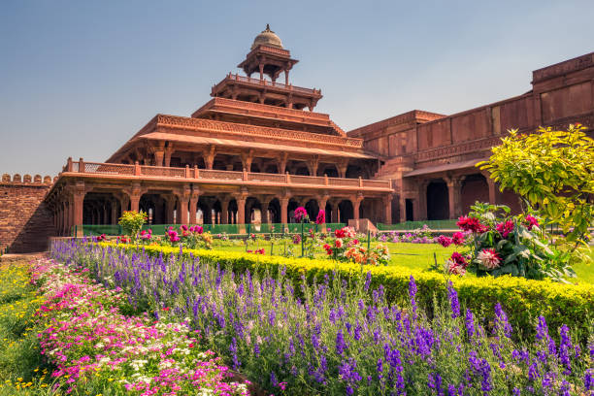
Fatehpur Sikri: The magnificent fortified city of Fatehpur Sikri, a UNESCO World Heritage Site, was built in 1569 by Emperor Akbar as the capital of his Mughal Empire. Despite its grandeur and meticulous planning, the city was abandoned merely 15 years later, reportedly due to a chronic scarcity of water, earning it the evocative title of a ghost city. As you explore this remarkably preserved complex, visit its most celebrated monuments, including the majestic Jami Masjid, one of the largest mosques of its time; the revered Tomb of Sheikh Salim Chishti, crafted in exquisite white marble; the five-storeyed Panch Mahal; and the impressive Diwan-i-Khas, famed for its central pillar and unique architectural design. The tour also includes views of various royal palaces that once formed the heart of Akbar’s courtly life. Fatehpur Sikri stands as a masterpiece of Mughal architecture, where Islamic design principles harmoniously merge with Hindu and Jain decorative elements, reflecting Emperor Akbar’s vision of cultural synthesis. The city remains a powerful testament to a brief yet brilliant chapter in India’s imperial history.

Continue drive to Agra. Upon arrival check in at hotel in Agra. Rest of the day free for relaxation.
Overnight stay at Agra hotel.

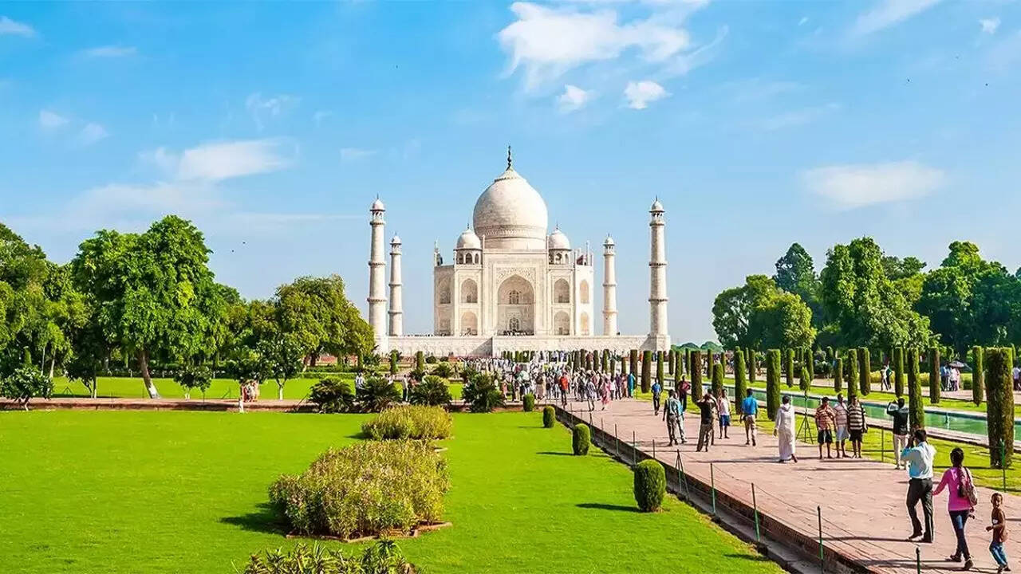
27TH FEB’26: AGRA
Morning after breakfast, proceed for a sightseeing tour of Agra, visiting Taj Mahal: Emperor Shah Jahan, a ruler renowned for his passion for architecture, resolved to create a marble memorial that would endure as one of the world’s most profound expressions of love and artistry. The site was deliberately chosen along a gentle bend of the Yamuna River, allowing the monument to be visible from Shah Jahan’s private chambers within Agra Fort, located further upstream. Construction of the Taj Mahal began in 1631 and spanned 22 years, engaging over 20,000 skilled artisans and craftsmen from across the empire and beyond. The result is a masterpiece that harmoniously balances monumental scale with exquisite detail, where architectural symmetry, refined proportions, and intricate marble inlay converge in perfect unity. The Taj Mahal stands today as a poignant mausoleum that blends subtlety with grandeur—an eternal symbol of devotion, aesthetic brilliance, and the zenith of Mughal architectural achievement.

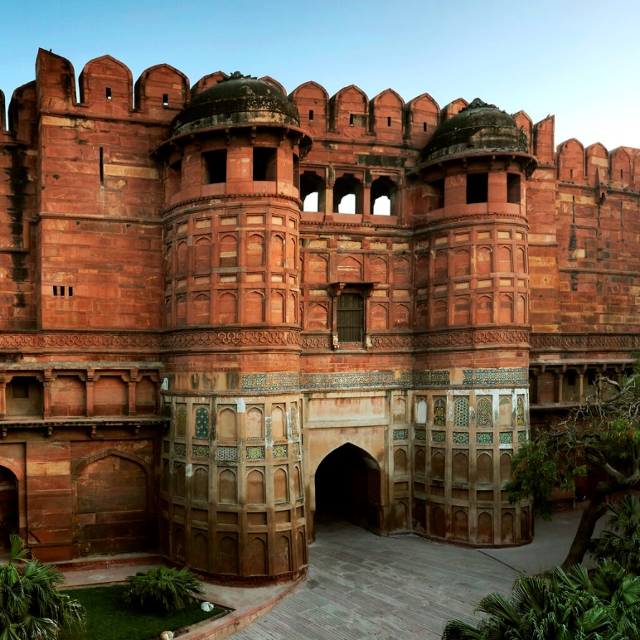
Agra Fort: The construction of Agra Fort, a UNESCO World Heritage Site, was initiated in 1565 by Emperor Akbar, marking the rise of Mughal power in northern India. Enclosed by formidable sandstone ramparts stretching over 2.5 kilometers and protected by a deep moat more than 10 metres wide, the fort stands as an imposing symbol of imperial strength and strategic brilliance. Far more than a military stronghold, Agra Fort functioned as a self-contained imperial city, housing palaces, mosques, audience halls, and administrative quarters. Within its walls, visitors encounter architectural masterpieces such as the elegant Moti Masjid (Pearl Mosque), the Diwan-i-Aam (Hall of Public Audience), and the richly ornamented Diwan-i-Khas (Hall of Private Audience). The complex also includes the Octagonal Tower, from where Emperor Shah Jahan is believed to have gazed upon the Taj Mahal, as well as Jahangir’s Palace, reflecting a blend of Hindu and Islamic architectural styles. Agra Fort remains a remarkable testament to Mughal architectural ingenuity and royal life, offering profound insights into the empire’s political, cultural, and artistic legacy.

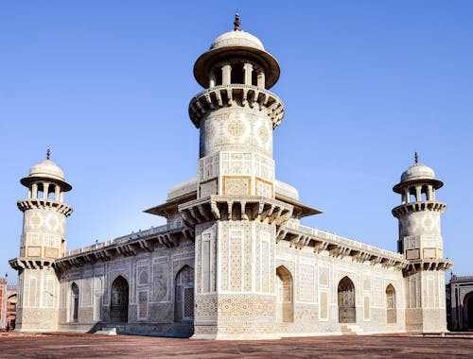
Itmad-Ud-Daula: Built in 1622, this exquisite mausoleum was commissioned for Ghiyas Beg, the father of Empress Nur Jahan, wife of Emperor Jahangir. Gracefully crafted in white marble, the tomb is adorned with delicate mosaic work, intricate pietra dura inlay, and fine lattice (jali) screens, reflecting a refined aesthetic that marked a significant transition in Mughal architecture.
Often referred to as the “Baby Taj,” the monument is notable as the first Mughal structure to be entirely clad in white marble with contrasting stone inlay, setting an important architectural precedent later perfected in the Taj Mahal. Unlike larger imperial mausoleums, Itimad-ud-Daulah’s Tomb possesses an intimate scale and a tranquil ambiance, offering visitors a sense of gentle serenity and understated elegance.

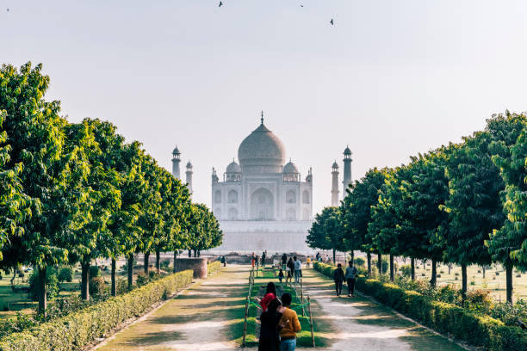
Mehtab Bagh is the last of the eleven Mughal gardens constructed along the Yamuna River, positioned directly opposite the Taj Mahal and Agra Fort, with Ram Bagh being the earliest of these landscaped gardens. Historical records attribute the original creation of this site to Emperor Babur (d. 1530), highlighting its early significance in Mughal garden design. Later, Emperor Shah Jahan identified the crescent-shaped, grass-covered floodplain across the Yamuna as an ideal vantage point for viewing the Taj Mahal. The garden was subsequently developed as a “moonlit pleasure garden,” known as Mehtab Bagh, offering a serene and symmetrical counterpoint to the monument across the river. Designed as an integral component of the Taj Mahal complex, Mehtab Bagh followed the classic Mughal riverfront terrace pattern, with its width precisely matching that of the Taj Mahal itself. The garden once featured white plastered walkways, elegant pavilions, reflective pools, and fountains, planted with fruit trees and fragrant flowers such as narcissus. Today, Mehtab Bagh provides one of the most tranquil and picturesque views of the Taj Mahal, especially at sunset and under moonlight.
Overnight stay at Agra hotel.

28TH FEB’26: AGRA – DELHI (239 Kms, 04Hrs drive)
Morning after breakfast drive to Delhi International airport to board flight for onward destination.

END OF TOUR

TOUR COST

Unit | Tour cost
Towards the cost for Golden Triangle Tour from 22ND Feb till 28TH Feb’26 | Euro 439per person

Hotels
City | Hotel Name | Dates | Nights
Delhi | Royal Plaza or similar | 22 – 24 Feb’26 | 02 Night
Jaipur | Fern Habitat or similar | 24 – 26 Feb’26 | 02 Night
Agra | Fairfield By Marriott or similar | 26 – 28 Feb’26 | 02 Night
Total number of nights |  |  | 07 Night

Cost includes:
- Accommodation based on a Double/Twin room as per the itinerary.
- Meal: Bed and breakfast as per program.
- All transfers, sightseeing tours & excursions by using 01 Airconditioned Toyota Innova Crysta as per the program.
- Local Greek/English speaking guide as per the program, except at Abhaneri, where the driver will assist for the same.
- Elephant ride at Amer Fort
- Government tax.

Cost excludes:
- Entry visa. Visas can be obtained online at: www.indianvisaonline.gov.in
- Tips for guides (at the client's discretion).
- Travel and cancellation insurance (optional).
- Beverages.
- Any services not mentioned as included, including personal extras such as telephone calls, laundry service, etc.

